Day 33 - 31st Aug 2026

VPC done by all — task 8

Cli based AWS task 9 —> still pending

Till 9.25

Task 1:
Amazon RDS (Relational Database Service) – a managed database instance (like MySQL) on AWS, connect to it, and test it.

Step 01:

Open RDS Service
RDS is AWS’s managed database service for MySQL, PostgreSQL, Oracle, SQL Server, and MariaDB.
AWS Console → Services → RDS
- Log in to AWS Console
- In the search bar, type RDS
- Click RDS to open the dashboard

Step 02:

Create Database Instance
Beginner Setup
You’ll launch a new managed database with free-tier options.
RDS Dashboard → Create database
- Choose Standard create
- Select MySQL (or PostgreSQL)
- Pick Free tier template
- Enter DB instance identifier (e.g., mydb-demo)
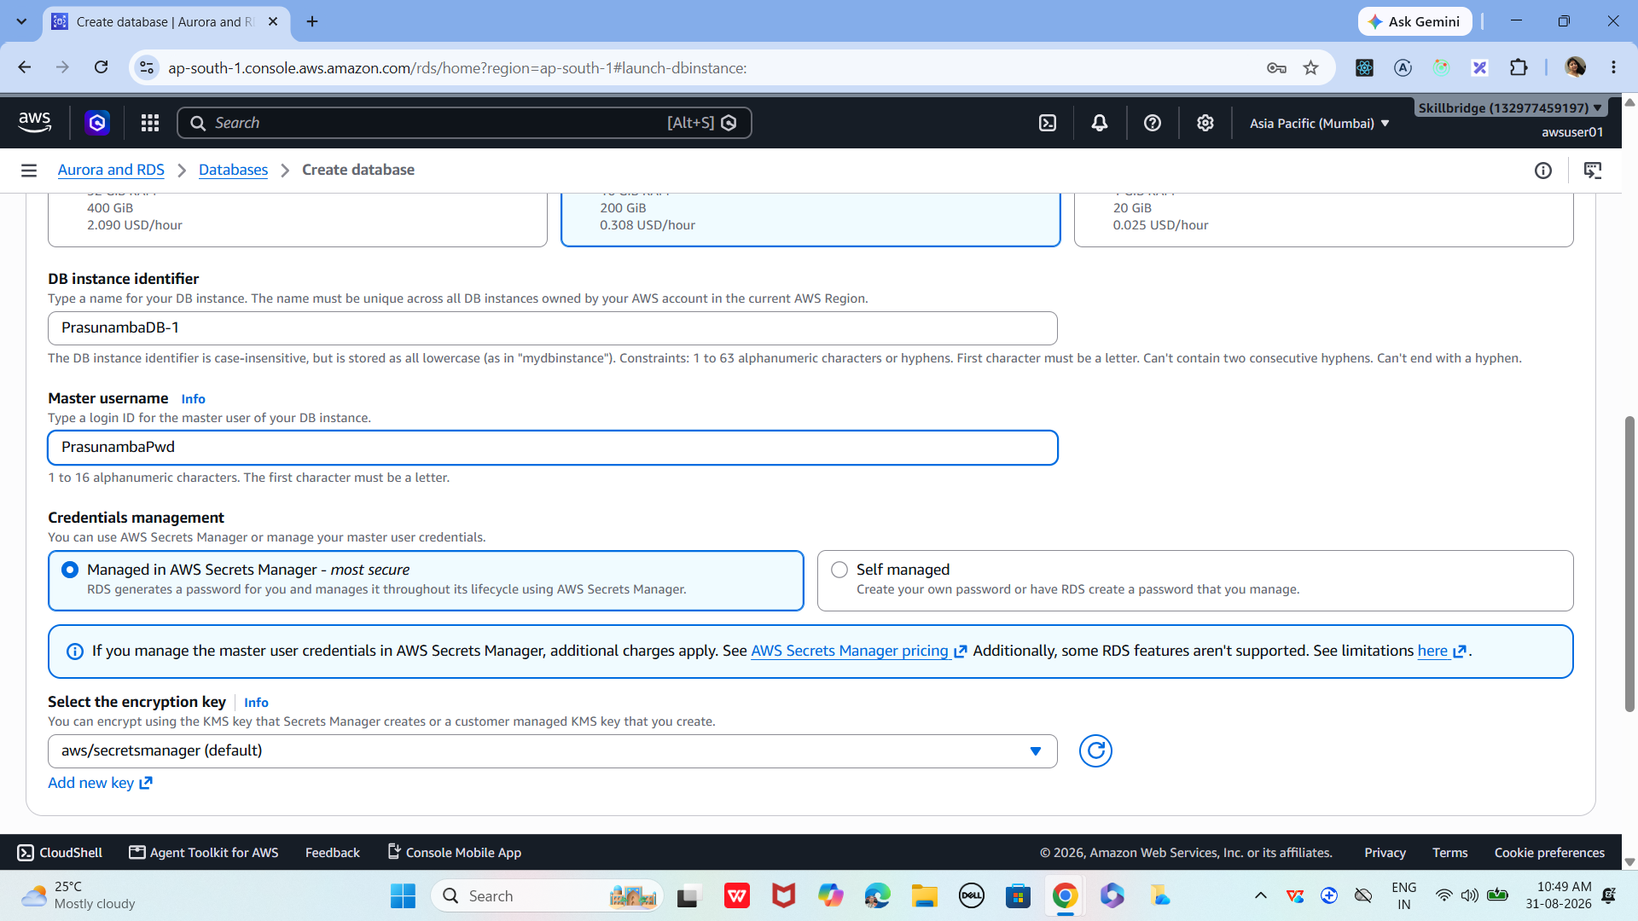

03

Configure Credentials
Set up the master username and password for database access.
- Enter Master username (e.g., admin)
- Enter a strong password
- Note these credentials — you’ll need them later

04

Choose Instance Size
Pick a small instance type suitable for beginners.
- Select db.t3.micro (free tier eligible)
- Keep storage defaults (20 GB)
- Disable autoscaling for demo

05

Set Connectivity
Configure how your database can be accessed.
- Select Default VPC
- Choose Public access → Yes (for demo)
- Pick or create a Security Group
- Add inbound rule: MySQL/Aurora (Port 3306) from your IP

06

Launch Database
AWS will now provision your managed DB instance.
- Click Create database
- Wait 5–10 minutes until status shows Available
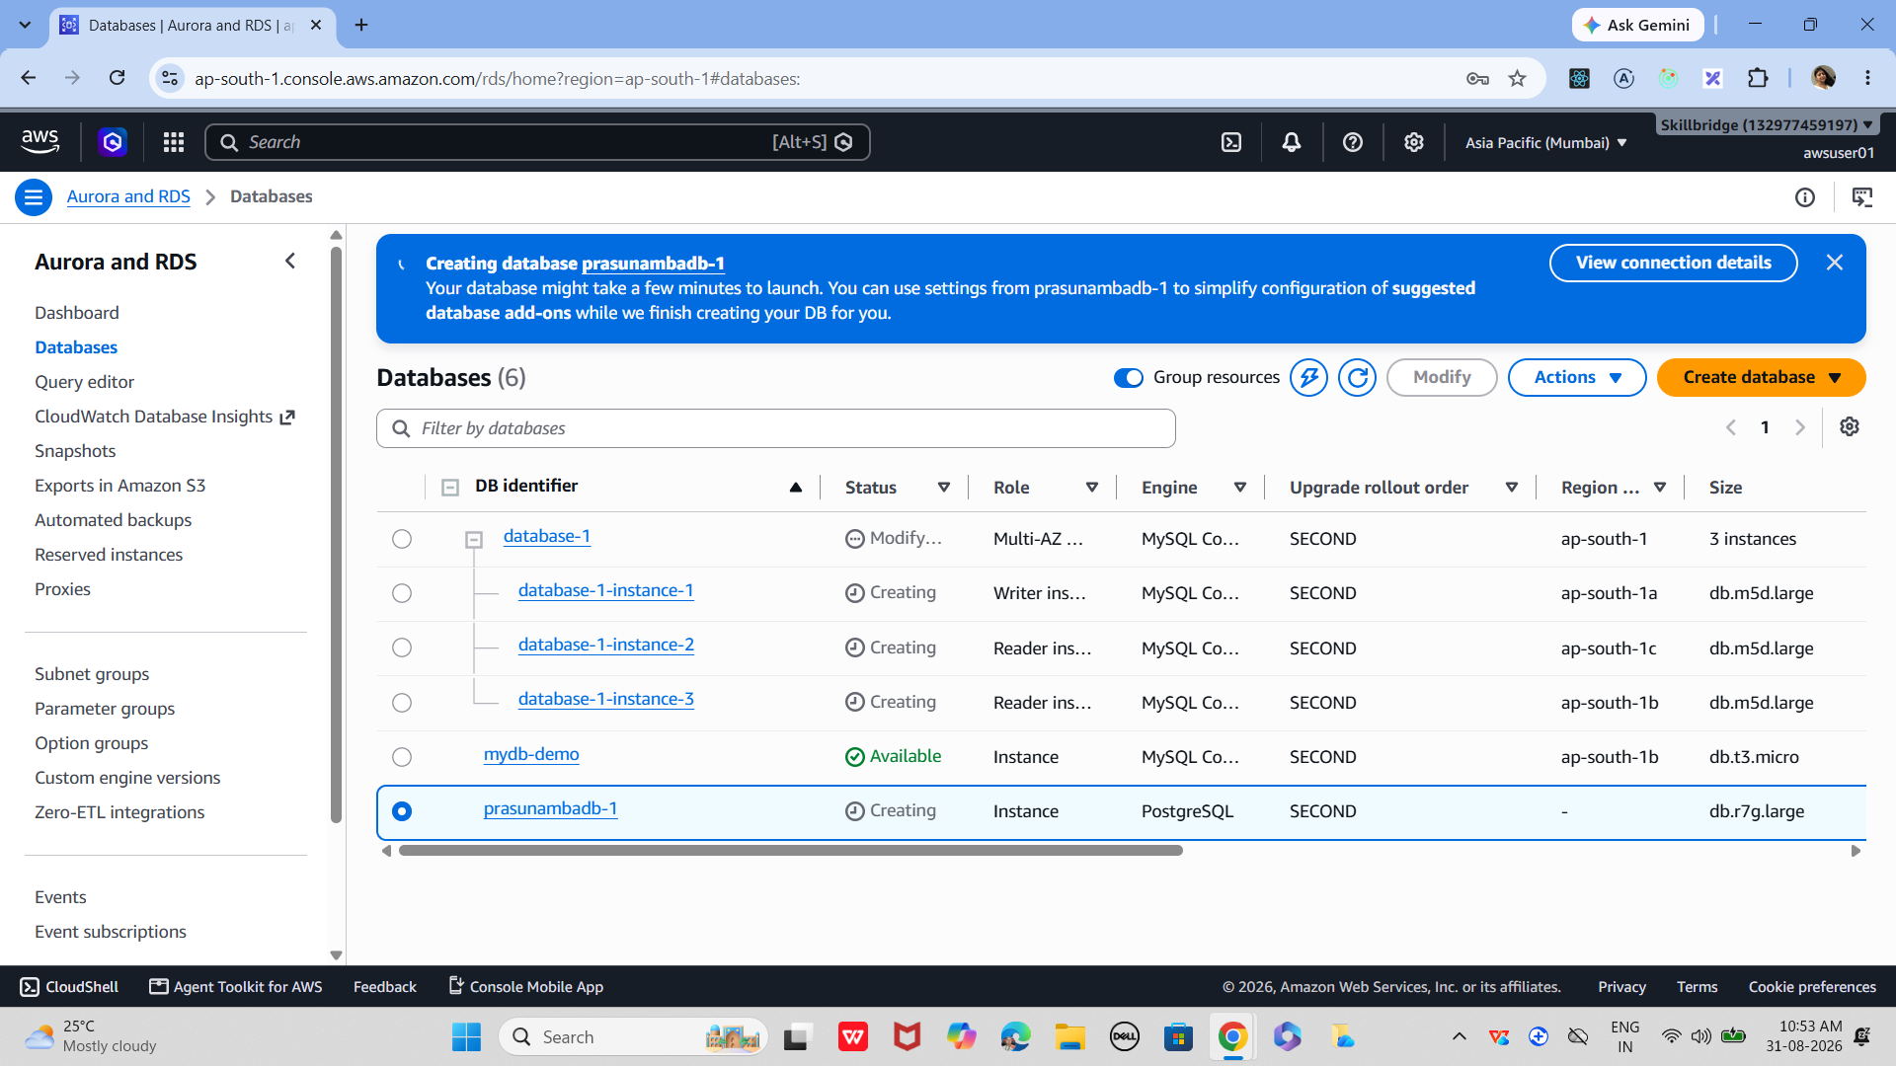

07

Connect via EC2 or Local Client
Use the endpoint provided by RDS to connect.
- Copy the Endpoint from RDS instance details
- From EC2 or local MySQL client, run:
bash
mysql -h <endpoint> -u admin -p

- Enter password → you’re inside the DB

08

Test Database
Verify that your database is working.
- Run SHOW DATABASES;
- Create a sample DB: CREATE DATABASE demo;
- Confirm with SHOW DATABASES;
Now we created a managed MySQL database on AWS RDS, connected to it, and tested it with basic SQL commands. The beauty of RDS is that AWS handles backups, patching, and scaling for you — so you focus on using the database, not maintaining servers
9.26 to 9.35
10.14 to 10.55
10.55 to 11.10 Break
Task 02:
Once done with RDS above Tsk 1.. Connect spring boot application that you have created with the DB .. using cloud
Steps for your reference are give at the end..of this doc
Done by:
- Monika
- Bharghav
- Pavan

Task 03:
AWS Security Groups and Basic Cloud Security . Security Groups act like virtual firewalls for your EC2 instances and RDS databases, controlling inbound and outbound traffic.

01

Open Security Groups in AWS Console
Security Groups are managed under the EC2 service.
AWS Console → EC2 → Network & Security → Security Groups
- Log in to the AWS Management Console
- Navigate to EC2 service
- On the left menu, click Security Groups

02

Create a New Security Group
Setup
Define a firewall set for your instance or database.
- Click Create Security Group
- Enter a name and description
- Select the VPC where your resources are running

03

Add Inbound Rules
Control what traffic can reach your instance.
- Choose Add Rule
- Select Type (e.g., SSH, HTTP, MySQL)
- Set Source (e.g., My IP for SSH, Anywhere for HTTP)
- Example: Allow MySQL/Aurora (3306) from your application server’s IP

04

Add Outbound Rules
Define what traffic your instance can send out.
- By default, all outbound traffic is allowed
- You can restrict it to specific destinations if needed

05

Attach Security Group to Resource
Apply the firewall rules to your EC2 or RDS instance.
- Go to your EC2 instance or RDS database
- Under Networking → Security Groups, click Edit
- Select the new security group and save changes

06

Test Connectivity
Best Practice
Verify that rules are working as expected.
- Try connecting via SSH or database client
- If blocked, check inbound rules
- Always restrict sensitive ports (e.g., SSH) to your IP only
You’ve now created and applied a Security Group to control access. This is the foundation of AWS cloud security — always follow the principle of least privilege (only open the ports and IPs you truly need).

real‑world AWS security demo where you secure an RDS database so that only your application server (EC2) can connect. that shows how Security Groups enforce isolation and controlled access.
Securing RDS with Security Groups

1. Launch Two Resources
- EC2 Instance (your application server).
- RDS Instance (e.g., MySQL).
Both must be in the same VPC for easy communication.

2. Create Security Groups
- AppServerSG → for EC2.
  - Inbound: Allow SSH (port 22) from your IP.
  - Outbound: Allow all (default).
- DBSG → for RDS.
  - Inbound: Allow MySQL (port 3306) only from AppServerSG.
  - Outbound: Allow all (default).
👉 Key point: Instead of opening RDS to the world (0.0.0.0/0), you restrict it to traffic coming from the EC2’s Security Group.

3. Attach Security Groups
- Assign AppServerSG to your EC2 instance.
- Assign DBSG to your RDS instance.

4. Test Connectivity
SSH into EC2:
bash
ssh -i mykey.pem ec2-user@<EC2-Public-IP>

Install MySQL client:
bash
sudo yum install mysql -y

Connect to RDS:
bash
mysql -h <RDS-ENDPOINT> -u admin -p
- ✅ Connection succeeds because EC2 is in the allowed SG.

5. Verify Security
Try connecting from your laptop directly:
bash
mysql -h <RDS-ENDPOINT> -u admin -p
- ❌ It fails — because your laptop’s IP is not allowed in DBSG.
- This proves only EC2 can talk to RDS.

6. Best Practices
- Always use least privilege: open only required ports.
- Use SG references (AppServerSG → DBSG) instead of IPs for dynamic scaling.
- Enable RDS encryption and automated backups for extra security.
- Consider IAM roles for EC2 → RDS authentication in advanced setups.
✨ Result: You’ve secured your RDS so that only your application server can connect. This is the foundation of network‑level security in
—-------------------------------------
Terraform Installation steps

https://developer.hashicorp.com/terraform/install#windows

Download
Extract to c:/terraform

Set path to env
Path add → new → c:/terraform

Check for version no
Terraform -version

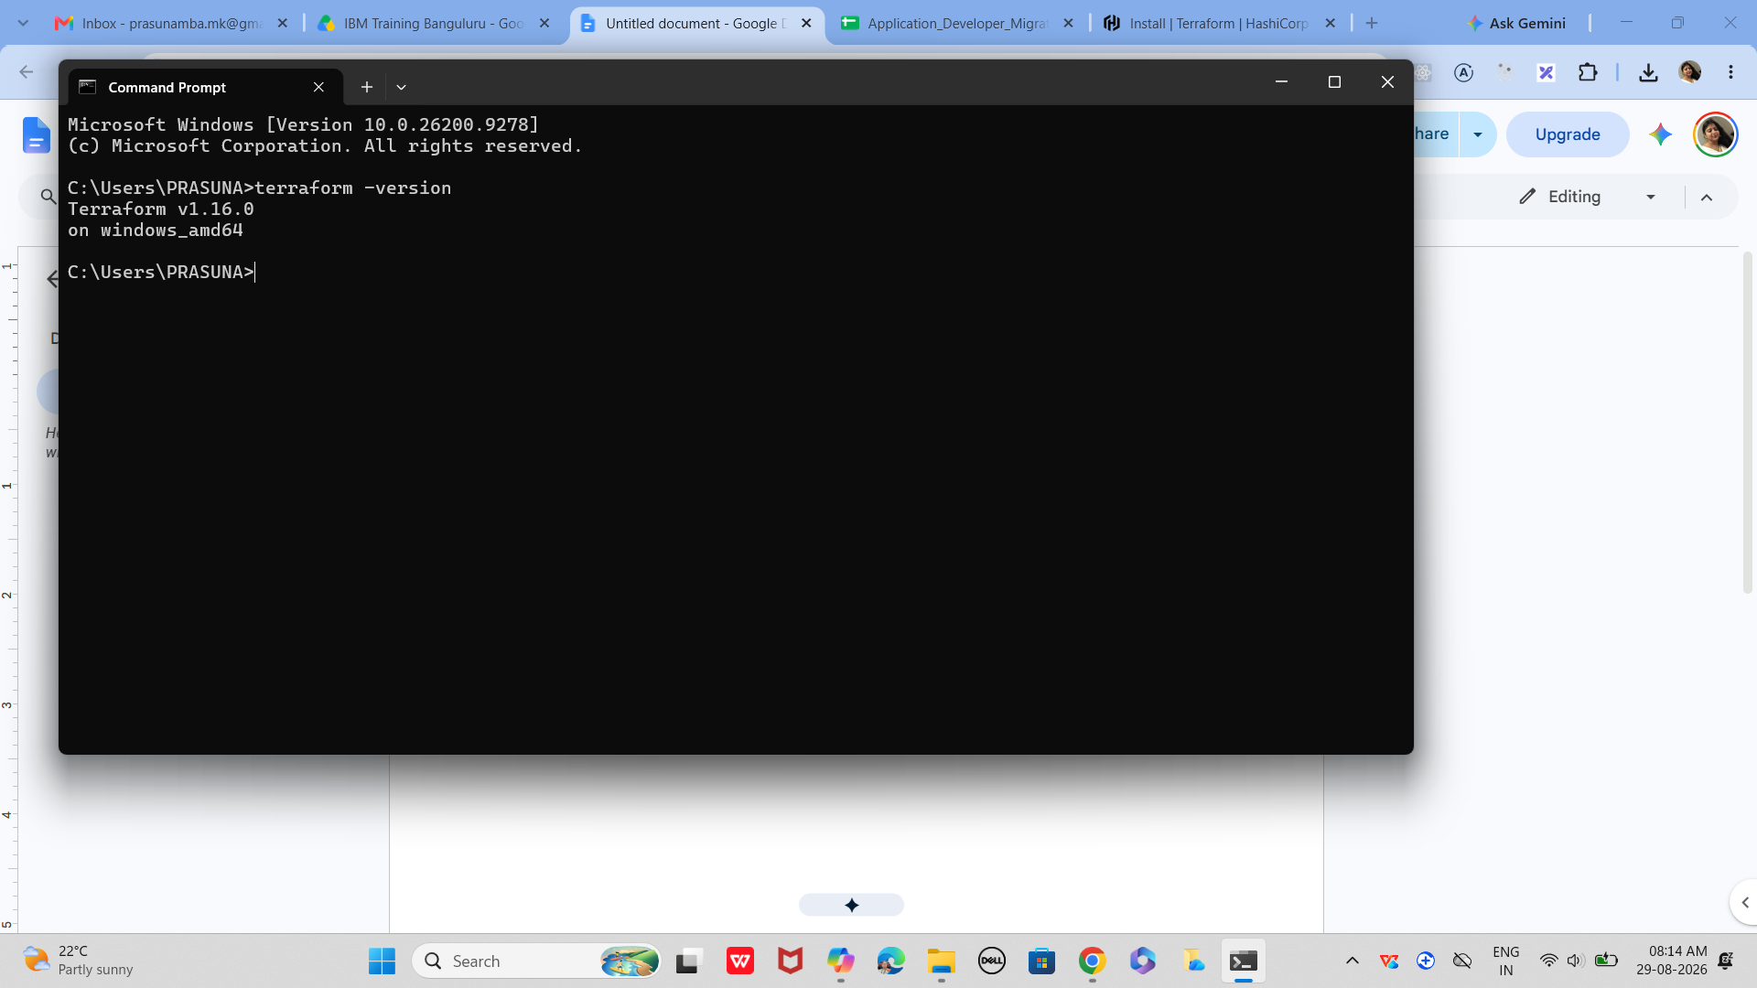
1 to 2 lunch break

Task 04:

Now lets create a project Terraform

Terraform-aws-demo
Project structure

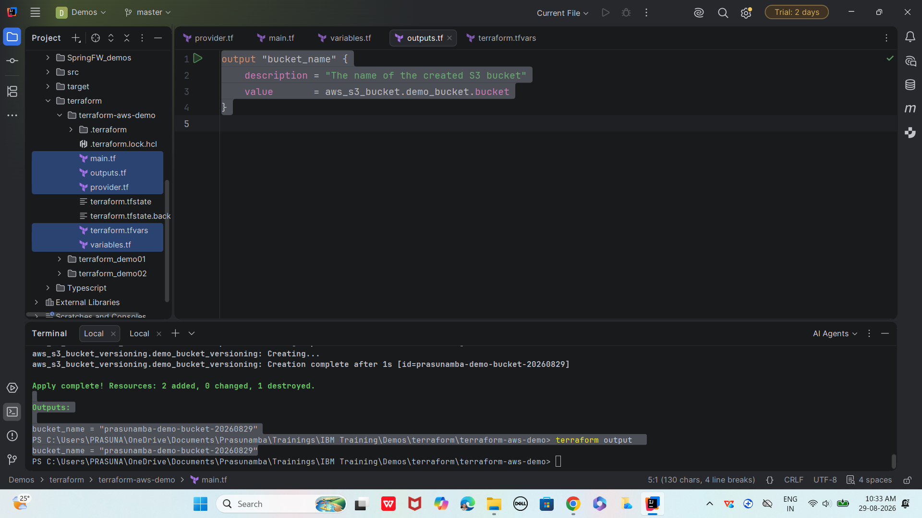

Step 1:

Create provider.tf

provider "aws" {
region = "ap-south-2"
}

variables.tf

variable "bucket_name" {
description = "Name of the Prasunamba's S3 bucket"
type = string
default = "prasunamba-demo-bucket-20260829"
}

main.tf

resource "aws_s3_bucket" "demo_bucket" {
bucket = var.bucket_name

tags = {
Name = var.bucket_name
Environment = "Demo"
Owner = "Prasunamba"
}
}

# Enable versioning (optional, production-style)
resource "aws_s3_bucket_versioning" "demo_bucket_versioning" {
bucket = aws_s3_bucket.demo_bucket.id
versioning_configuration {
status = "Enabled"
}
}

Terraform.tfvars

bucket_name = "prasunamba-demo-bucket-20260829"

outputs.tf
output "bucket_name" {
description = "The name of the created S3 bucket"
value = aws_s3_bucket.demo_bucket.bucket
}

Step 2:

1️⃣ Initialize Terraform
This sets up the working directory and downloads the AWS provider plugin.
cmd
terraform init

2️⃣ Validate Configuration
Check if your .tf files are syntactically correct.
cmd
terraform validate

3️⃣ Plan Infrastructure
Preview what Terraform will create before applying.
cmd
terraform plan

4️⃣ Apply Infrastructure
Actually create the S3 bucket in AWS.
cmd
terraform apply
Terraform will ask for confirmation:
Code
Do you want to perform these actions?
Terraform will perform the actions described above.
Only 'yes' will be accepted to approve.

Enter a value: yes
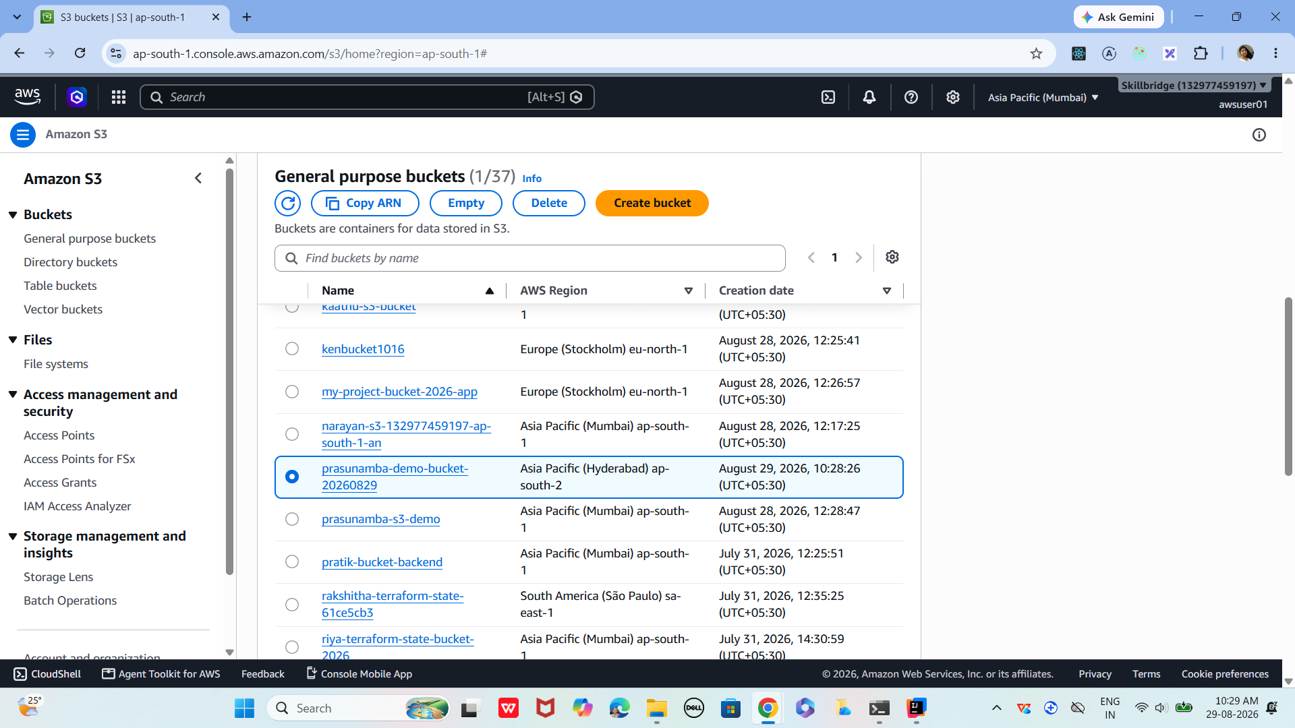

5️⃣ Output Values (Optional)
If you define outputs in outputs.tf, you can view them:
cmd
terraform output
Example outputs.tf:
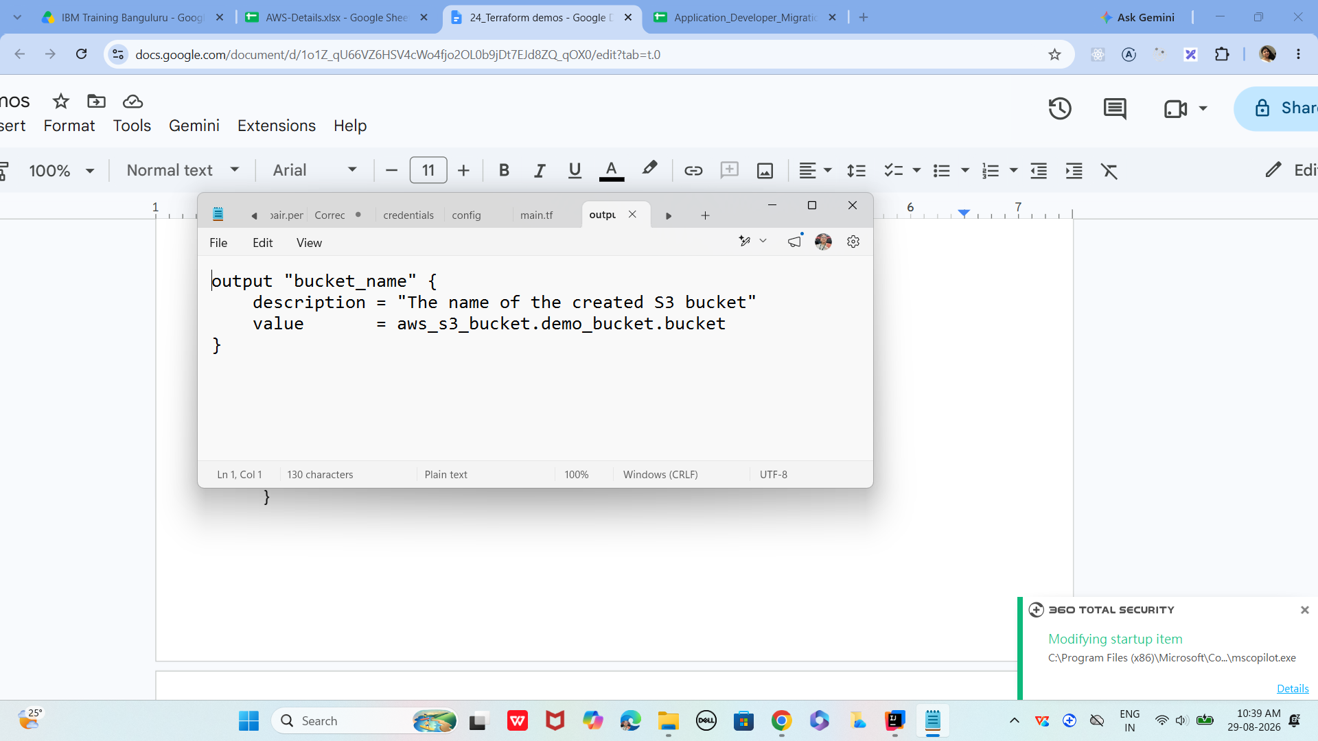

Plz dont destroy..
Task 05 is in continuation with task 4

6️⃣ Destroy Infrastructure (Cleanup)
When you’re done, remove everthing:
cmd
terraform destroy
Confirmation prompt:
Code
Do you really want to destroy all resources?
Only 'yes' will be accepted to confirm.

Enter a value: yes
So far covered
- Providers (connect to cloud APIs)
- Resources (define infrastructure objects)
- Workflow (init → plan → apply → destroy)
full lifecycle demo: init → validate → plan → apply → output → destroy

Task 5:
Next is adding Data Sources → aws_caller_identity.current, aws_region.current
In continuation with above project
In main.tf

# Data Source: Fetch current AWS caller identity (account info)
data "aws_caller_identity" "current" {}

# Data Source: Fetch current AWS region
data "aws_region" "current" {}

outputs.tf

output "bucket_name" {
description = "The name of the created S3 bucket"
value = aws_s3_bucket.demo_bucket.bucket
}

output "account_id" {
description = "AWS Account ID from data source"
value = data.aws_caller_identity.current.account_id
}

output "region" {
description = "AWS Region from data source"
value = data.aws_region.current.name
}

Run all steps from init

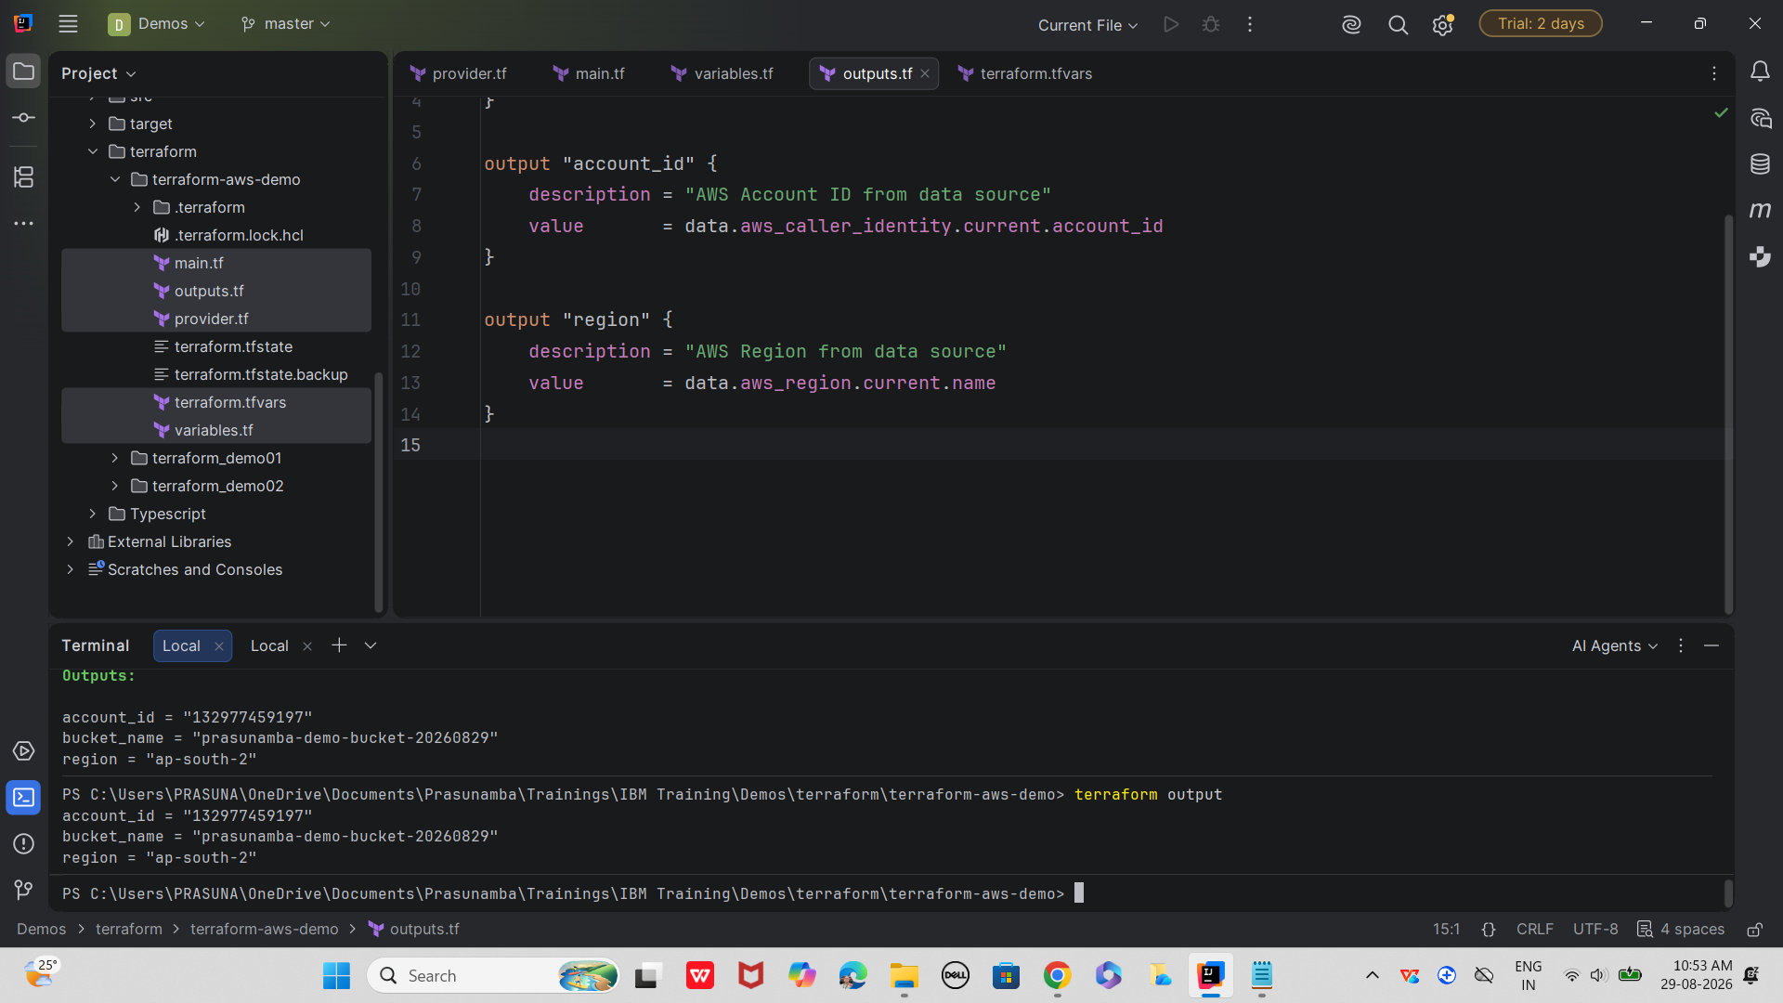

In short: after adding data sources, you’ll see extra read operations in plan/apply, new outputs, and the ability to inject dynamic AWS info into your resources

Plz refer home task …. At the end of the doc.. Named Home Task
Done by 👍
- Pavan
- Karthik
- Monika
- Sujal
- Harsh
- Adarsh
- Nargvalli
- Vicky
- Shiraz
- Keerthi

Upcoming Assessment Schedule 👍

TypeScript Fundamentals | Assessment 5 | 31st Aug 2026 Mon
Angular
React
Database Development Fundamentals | Assessment 6 | 1st Sept 2026 Tues
Redis & Caching
PostgreSQL
Database Schema Migration & Data Persistence
Assessing a Brownfield Application for Migration or Modernization | Assessment 7 | 2nd sept 2026 Wed
Cloud-Native Application Design (12-Factor App)
Legacy Refactoring & Application Decomposition (DDD)
Node.js
Spring Framework | Assessment 8 | 3rd sept 2026 Thurs
Spring Boot
Microservices Software Architecture: Patterns and Techniques
Messaging & Event-Driven Architecture
Deployment Cutover Strategies | Assessment 9 | 4th sept 2026 Fri
AWS Cloud Fundamentals
Application Security
Application Observability
AI-Assisted Software Development
Terraform | Assessment 10 | 7th sept 2026 Mon
Docker
Kubernetes
Ansible
CI/CD with Jenkins Ansible Docker Kubernetes

—---------------------------------------------------------------------------------------------------------------------

Demo: Spring Boot + AWS RDS (MySQL)

1. Prerequisites - ensure
- AWS account with RDS MySQL instance running (from our earlier demo).
- Instance endpoint (e.g., mydb.xxxxx.rds.amazonaws.com).
- Database name, username, and password.
- Java 17+ and Maven installed locally.

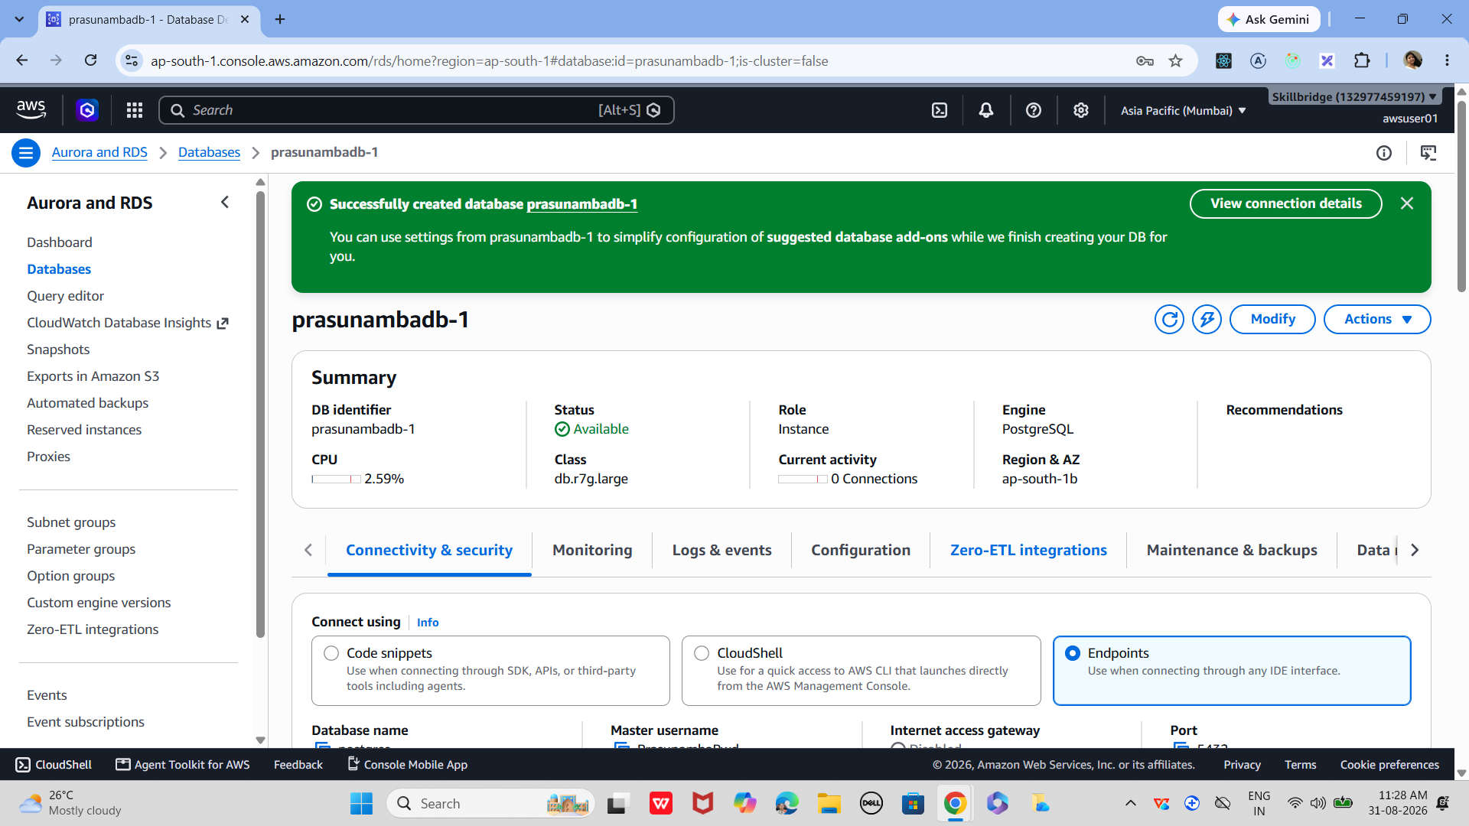
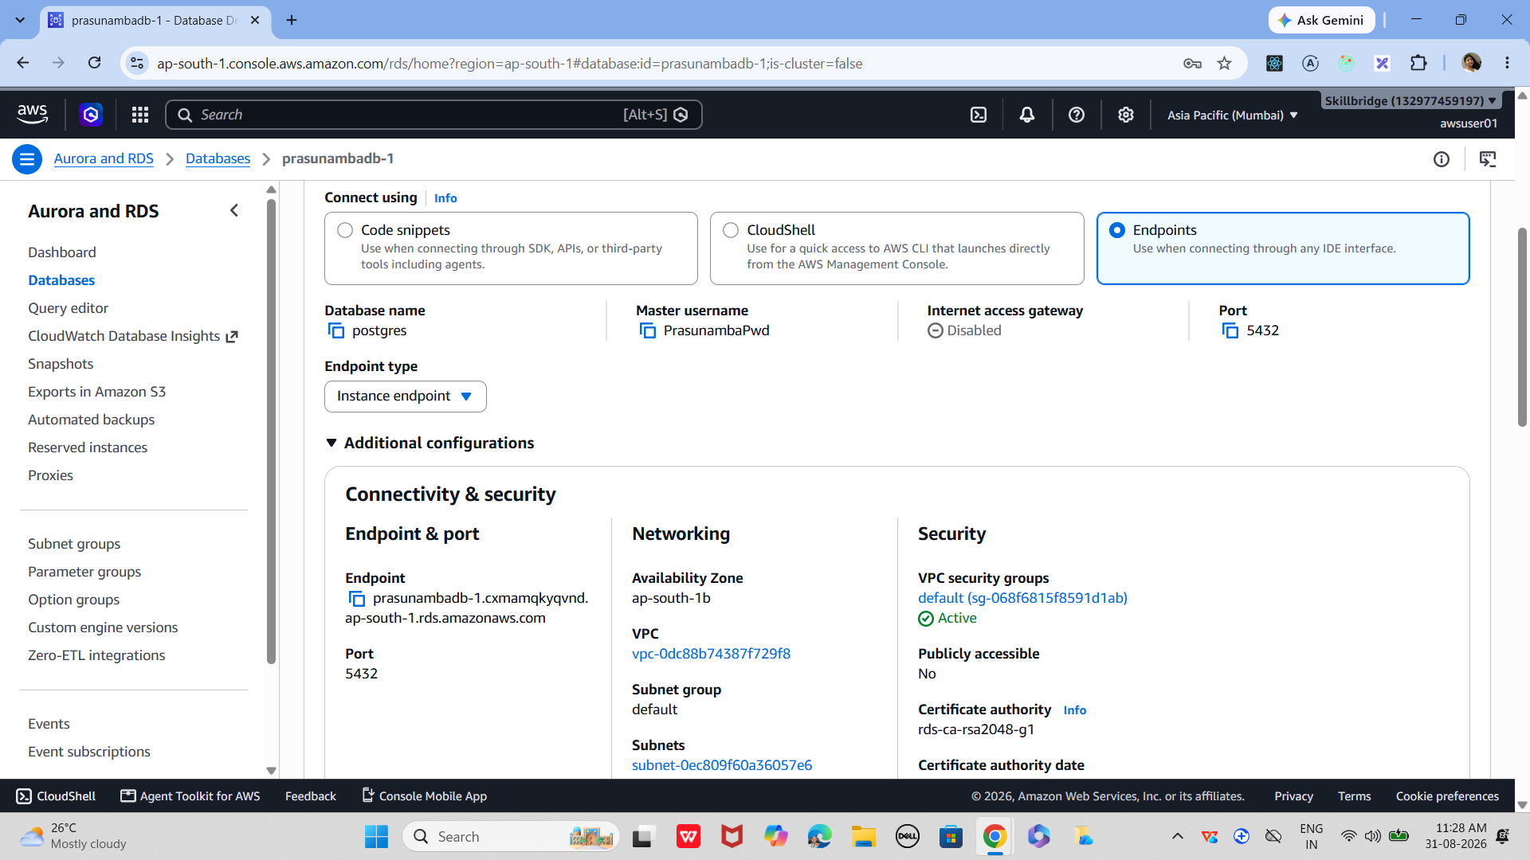

2. Create Spring Boot Project
Use Spring Initializr (https://start.spring.io):
- Project: Maven
- Language: Java
- Dependencies:
  - Spring Web
  - Spring Data JPA
  - MySQL Driver
Download and unzip the project.

3. Configure application.properties
In src/main/resources/application.properties:
properties
spring.datasource.url=jdbc:mysql://mydb.xxxxx.rds.amazonaws.com:3306/demo_db
spring.datasource.username=admin
spring.datasource.password=YourPasswordHere
spring.jpa.hibernate.ddl-auto=update
spring.jpa.show-sql=true
spring.jpa.properties.hibernate.dialect=org.hibernate.dialect.MySQL8Dialect

4. Create an Entity
java
package com.example.demo.model;

import jakarta.persistence.Entity;
import jakarta.persistence.GeneratedValue;
import jakarta.persistence.GenerationType;
import jakarta.persistence.Id;

@Entity
public class Employee {
@Id
@GeneratedValue(strategy = GenerationType.IDENTITY)
private Long id;
private String name;
private String role;

// getters and setters
}

5. Repository Interface
java
package com.example.demo.repository;

import com.example.demo.model.Employee;
import org.springframework.data.jpa.repository.JpaRepository;

public interface EmployeeRepository extends JpaRepository<Employee, Long> {
}

6. REST Controller
java
package com.example.demo.controller;

import com.example.demo.model.Employee;
import com.example.demo.repository.EmployeeRepository;
import org.springframework.web.bind.annotation.*;

import java.util.List;

@RestController
@RequestMapping("/employees")
public class EmployeeController {

private final EmployeeRepository repo;

public EmployeeController(EmployeeRepository repo) {
this.repo = repo;
}

@GetMapping
public List<Employee> getAll() {
return repo.findAll();
}

@PostMapping
public Employee addEmployee(@RequestBody Employee emp) {
return repo.save(emp);
}
}

7. Run the Application
bash
mvn spring-boot:run

8. Test with Postman / Curl
- Add employee:
bash
curl -X POST http://localhost:8080/employees \
-H "Content-Type: application/json" \
-d '{"name":"Alice","role":"Trainer"}'

- Get employees:
bash
curl http://localhost:8080/employees

This will store and retrieve data directly from your AWS RDS MySQL instance.
You now have a Spring Boot REST API connected to AWS RDS.

++++++++++++++++++++++++++++++++++++++++++++++++++++++++++++++++++++++++
Home Task ++++++++++++++++++++++++++++++++++++++++++++++++++++++++++++++++++++++++
Can you create a Node.js
- API Authentication & Security (JWT)
- Sorting, Pagination, and Filtering
- Testing with Jest + Supertest

📂 Project Structure
Code
task-app/
│── package.json
│── server.js
│── config/
│ └── db.js
│── models/
│ └── Task.js
│ └── User.js
│── routes/
│ └── taskRoutes.js
│ └── userRoutes.js
│── middleware/
│ └── authMiddleware.js
│── controllers/
│ └── taskController.js
│ └── userController.js
│── tests/
│ └── task.test.js

Execution steps

1

Initialize Project
Set up Node.js project with dependencies.
- Run npm init -y
- Install packages: npm install express mongoose bcryptjs jsonwebtoken dotenv jest supertest

2

Database Connection
Configure MongoDB connection.
- Create config/db.js
- Use mongoose.connect(process.env.MONGO_URI)
- Add error handling

3

User Authentication
Implement JWT-based login and signup.
- Create User.js model with email & password
- Hash password using bcrypt
- Generate JWT with jsonwebtoken
- Middleware verifies token

4

Task CRUD APIs
Build routes for tasks with security.
- Create Task.js model (title, completed, user)
- Protect routes with authMiddleware
- Implement CRUD in taskController.js

5

Sorting, Pagination, Filtering
Enhance GET tasks API.
- Use query params: ?completed=true&sort=createdAt&limit=5&page=2
- Apply .find() with .sort(), .skip(), .limit()

6

Testing APIs
Write Jest + Supertest tests.
- Create task.test.js
- Test signup/login
- Test protected task routes
- Test sorting & pagination

7

Run Project
Start server and run tests.
- Run node server.js
- Run tests: npm test
- Use Postman or curl to test APIs

🔑 Key Code Files

server.js
js
const express = require('express');
const dotenv = require('dotenv');
const connectDB = require('./config/db');
const userRoutes = require('./routes/userRoutes');
const taskRoutes = require('./routes/taskRoutes');

dotenv.config();
connectDB();

const app = express();
app.use(express.json());

// Routes
app.use('/api/users', userRoutes);
app.use('/api/tasks', taskRoutes);

const PORT = process.env.PORT || 5000;
app.listen(PORT, () => console.log(`Server running on port ${PORT}`));

models/User.js
js
const mongoose = require('mongoose');
const bcrypt = require('bcryptjs');

const userSchema = mongoose.Schema({
email: { type: String, required: true, unique: true },
password: { type: String, required: true }
});

// Hash password before saving
userSchema.pre('save', async function(next) {
if (!this.isModified('password')) return next();
this.password = await bcrypt.hash(this.password, 10);
next();
});

// Compare password
userSchema.methods.matchPassword = async function(enteredPassword) {
return await bcrypt.compare(enteredPassword, this.password);
};

module.exports = mongoose.model('User', userSchema);

middleware/authMiddleware.js
js
const jwt = require('jsonwebtoken');

const protect = (req, res, next) => {
let token = req.headers.authorization?.split(" ")[1];
if (!token) return res.status(401).json({ message: "Not authorized" });

try {
const decoded = jwt.verify(token, process.env.JWT_SECRET);
req.user = decoded.id;
next();
} catch (error) {
res.status(401).json({ message: "Token failed" });
}
};

module.exports = protect;

controllers/taskController.js
js
const Task = require('../models/Task');

// Create Task
exports.createTask = async (req, res) => {
const task = await Task.create({ title: req.body.title, user: req.user });
res.json(task);
};

// Get Tasks with Sorting, Pagination, Filtering
exports.getTasks = async (req, res) => {
const { completed, sort, page = 1, limit = 5 } = req.query;
const query = completed ? { completed } : {};
const tasks = await Task.find(query)
.sort(sort)
.skip((page - 1) * limit)
.limit(Number(limit));
res.json(tasks);
};

tests/task.test.js
js
const request = require('supertest');
const app = require('../server');

describe("Task API", () => {
it("should register a user", async () => {
const res = await request(app).post("/api/users/register").send({
email: "test@example.com",
password: "123456"
});
expect(res.statusCode).toEqual(201);
});

it("should login user and return token", async () => {
const res = await request(app).post("/api/users/login").send({
email: "test@example.com",
password: "123456"
});
expect(res.body.token).toBeDefined();
});
});

✅ With this setup, you now have:
- Secure JWT authentication
- Task APIs with sorting, pagination, filtering
- Automated tests with Jest +

